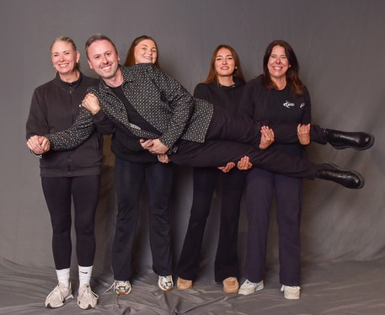

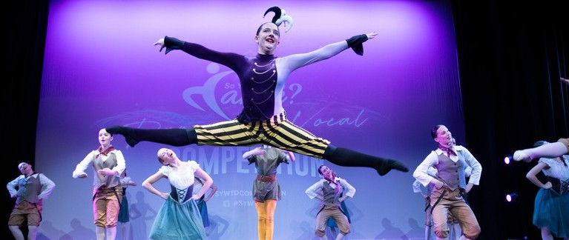
So You Want To Dance is one of the UK's biggest and
longest-running dance competitions. It is a place where every dancer gets a real stage, real judges, and a real opportunity to shine.
We treat every competitor with the same respect, care
and professionalism, whether it's their first performance or their tenth. Dance schools return to us season after season because they trust us and because their students go home inspired.
Professional judges · Theatre venues · All styles welcome · Over £100,000 in prizes every season
soyouwanttodance.uk
Your stage is waiting.dance@soyouwanttodance.uk | 07723 616 442
SSOO YYOOUU WWAANNTT TTOO DDAANNCE
IINNFFOORRMMAATTIIOONN PPAACCKK
Your stage is waiting.
2011
EST.
15
YEARS OF EXCELLENCE
Over £10K+
ANNUAL PRIZES
3
PRO JUDGES PER EVENT
£30K+
TOP SCHOLARSHIP AT OUR GRAND FINAL
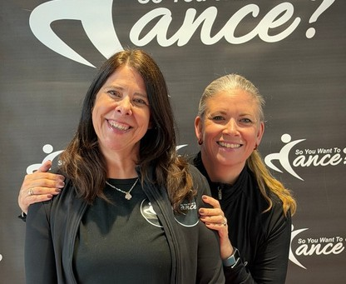

ABOUT
FOUNDERS & DIRECTORS
Hi, we’re Gaynor & Jodie-Anne - two sisters from Leeds who started dancing at the age of two and have never looked back. From our years working as professional dancers and teachers, we saw the need to create a safe, guided, and fun space for performers to shine and push the boundaries of their comfort zones.

In 2011, we held our first-ever event in Canterbury at The Gulbenkian Theatre. That first competition was electric, and that was enough for us to know we were onto something special. Year by year, we added new venues, new events, and new opportunities.

SYWTD is now one of the UK's most established competitions, and as of May 2026, has entered its 16th year.

We built every bit of it from a shared love of dance and a belief in young talent, and we can’t wait to share that with you

Here's why dance schools and families choose us year after year
WHAT MAKES SYWTD DIFFERENT

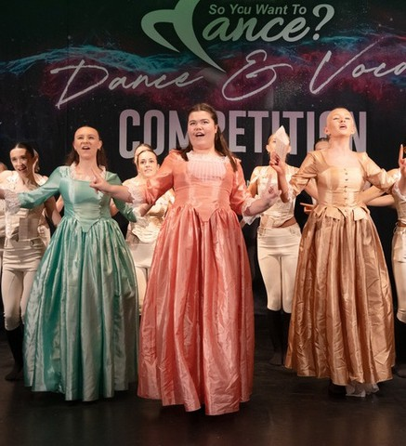

OUR SPONSORS
WHY CHOOSE SYWTD?
Industry professional judges
Every judge is currently working in the dance world, from West End musical stars and professional dance college tutors, to backing dancers on tour, cruise ship performers and actors. These are the people who can genuinely shape a dancer's future.

Theatre Venues Across the UK
We don't do function rooms. Every SYWTD event is held in a professional theatre venue with proper stages, proper lighting, and proper sound. The environment that prepares dancers for the real world.

Written Feedback From The Judges
Every routine receives written feedback from one of our judges. Real, constructive guidance that teachers and dancers can take home and act on.

All Styles. All Ages. All Welcome.
Ballet, tap, jazz, modern, acrobatics, street, commercial, contemporary, lyrical, song and dance, vocal and national. Every style has a place on our stage.

Always Run on Time
We know your day is precious. Our events are meticulously planned and always run to schedule.


THE BRIGHTON ACADEMY

One of the UK's most respected professional dance training
colleges. The Brighton Academy provides one of our judges at every event* and sponsors our Grand Final scholarship. Several So You Want To Dance alumni are currently training at The Brighton Academy

*Except when unable to due to TBA shows and auditions

MEPA
MEPA is a dynamic college dedicated to fostering creativity, performance and excellence in the arts. With a strong focus on developing talent in musical theatre, singing, dance, and acting, MEPA award a full three-year funded scholarship at our Grand Final.
We are also delighted to be able to offer a series of funded associate and summer school places, as well as workshops from sponsors:
- Sam Stanley Associates
- Kimberly Wyatt Dance Academy
- Base Dance Studios and many more

Always A Good Time - We are known for bringing
£10,000+
£30,000+
West End
Cash prize fund
a
cross the season
The Brighton A r
cademy 3-yea
scholarshipMM
Workshops with
in als
dustry profession
Taster Weeks
At professional dance colleges
soyouwanttodance.uk
Your stage is waiting.dance@soyouwanttodance.uk | 07723 616 442
good vibes and making the audience laugh

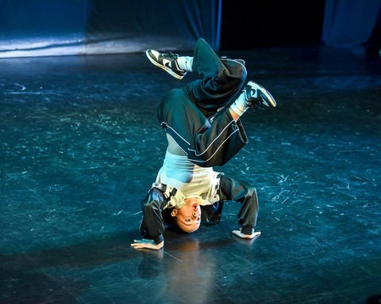




ENTRY PRICES 2026
Everything you need to know about entering
HOW IT WORKS
Solos £24
Duets and Trios £12.50 per dancer Troupes £11 per dancer
*Once an event is full, a deposit secures your place. Full fees are due 8 weeks prior to the competition date.
Prices will increase in 2027 Solos £26, Duet/Trio £15 & Troupes £12
Spectator ticket prices - £18 Adult one day £9 Child, £30 2-day ticket £15 Child.

Genres
Classical Ballet, Lyrical, Contemporary, Tap, Modern, Jazz
Street, Commercial, Song & Dance, Vocal & Musical Theatre
Acrobatics, Character & National


Adult
18 and over
Age is determined by the dancer's age on the day of the competition. For duets, trios and troupes, age is based on the average age of all Performers.
AGE CATEGORIES
Age Group | Age
Tiny | 5 and under
Mini | 6 – 8
Junior | 9 – 11
Inter | 12 – 14
Senior | 15-17

FORMATS
Solos - Duets - Trios - Troupes

ROUTINE TIMING
Solo: 2 minutes maximum
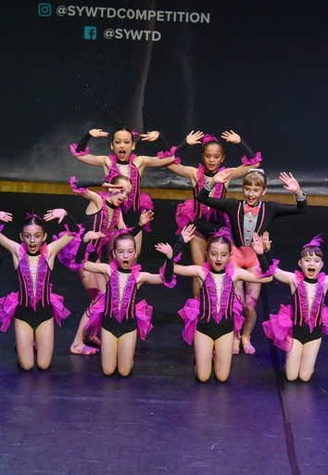
Duet / Trio: 2.5 minutes maximum Troupe: 4 minutes maximum
All entries must be submitted online through your dance school
Entries are accepted on a first-come, first-served basis. Solo performers may not repeat the same genre more than once
Troupes must have a minimum of 4 dancers
- Music and costumes must be appropriate for family viewing All routines are scored by 3 judges, with written feedback provided by one judge per routine
Routines placing 1st, 2nd or 3rd, or scoring 245+ marks will qualify for a National Final. Mini and Novice dancers who score 230 will also qualify in their sections

SPECTATOR TICKETS
Spectator tickets are available for all SYWTD events. Come and support your dancer on a real theatre stage. Visit soyouwanttodance.uk/tickets for pricing and booking. Some tickets will be available at the door.

CHAPERONES & SAFEGUARDING

All dancers are the sole responsibility of their dance school All entrants under 16 must be chaperoned by a dance school-nominated adult
All named chaperones must have current DBS clearance details registered with SYWTD prior to the event
1 free teacher/chaperone wristband per 10 competing children
Only registered chaperones will be permitted backstage

1. Register Online
soyouwanttodance.uk
Your stage is waiting.dance@soyouwanttodance.uk | 07723 616 442
› 2. Enter Your Routines ›
3. Confirm & Pay
› 4. Compete on Stage ›
5. Win Prizes!



PRIZES & SCHOLARSHIPS WHAT PEOPLE SAY ABOUT SYWTD

The moments that make it all worthwhile
PRIZES, AWARDS & WHAT PEOPLE SAY
GRAND FINAL TOP PRIZE



3-Year The Brighton Academy Scholarship | Worth £30,000+

soyouwanttodance.uk · All styles · All ages · Real stages · Real judges · Real prizes
soyouwanttodance.uk
Your stage is waiting.dance@soyouwanttodance.uk | 07723 616 442

Annual Cash Prize Fund
Over £100,000 across the season

West End Workshops
With industry professionals Professional College Taster Weeks Experience life at a dance college Dance Intensive Courses Participation Medal
Every troupe performer will leave with a medal

Placing Medals
For 1st, 2nd, 3rd and 4th in every category

HOW TO QUALIFY FOR THE GRAND FINAL

Every routine that places 1st, 2nd, or 3rd, or scores 240+ marks, Mini/Novice 230 marks earns a place at the SYWTD National Final.

SPECIAL AWARDS
All dancers are automatically considered for all special awards; there is no extra fee.


Highest Scoring Solo In Each Age Range Standout Solo, Duet & Trio and Group Best Choreography
Host Award
Most Promising Dancer Judges’ Special Award Overall Winner of the Day

GET IN TOUCH
dance@soyouwanttodance.uk 07723 616 442
Mon / Tue / Fri 9am–4pm
“I’ve made the most incredible memories at SYWTD over the
years! You have watched and helped me grow from a young, scared little dancer to now the principal of my own school, and I couldn’t be more grateful for the opportunities you have given my students and me over the years.

Your last competition in March was honestly one of the best days of my entire life! I didn’t realise that dreams like this could even be possible for me, but you made them come true, and I will be forever grateful.”

Eleanor Clark Dance Company

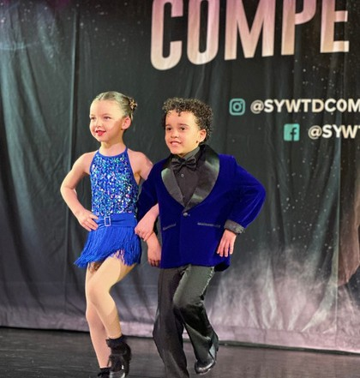

REGISTER NOW — 2026/2027 DATES ARE OPEN

